AI-Driven Security Operations Center using Agentic AI, Elasticsearch, and Kibana for Threat Detection, Classification, and Alerting

Shrey Rajesh Mishra
Department of Computer Engineering,
Shree L.R. Tiwari College of Engineering, Mumbai shrey.r.mishra@slrtce.in
Sujal Samar Das Department of Computer Engineering,
Shree L.R. Tiwari College of Engineering, Mumbai sujal.s.das@slrtce.in
Soniya Sobhan Kolay Department of Computer Engineering,
Shree L.R. Tiwari College of Engineering,Mumbai sonia.s.kolay@slrtce.in

Tejashree Hanumantha Chalwadi
Department of Computer Engineering, Shree L.R. Tiwari College of Engineering, Mumbai Tejashree.h.chalwadi@slrtce.in
Mrs.Neelam Phadnis
Assistant Professor and Dean,
Department of Computer Engineering, Shree L.R. Tiwari College of Engineering, Mumbai
neelam.phadnis@slrtce.in

Introduction
Cybersecurity threats have evolved into dynamic, persistent, and highly adaptive attacks that challenge traditional detection systems. With the rise of the Internet of Things (IoT), cloud platforms, and distributed architectures, the attack surface has expanded exponentially. Conventional Security Operations Centers (SOCs) rely on manual triage and static correlation rules, resulting in delayed detection, false positives, and analyst fatigue.
Artificial Intelligence (AI) and Machine Learning (ML) techniques have transformed this domain by enabling automated anomaly detection, predictive modeling, and behavior analysis. However, many existing AI-based Intrusion Detection Systems (IDS) lack contextual awareness, autonomous reasoning, and real-time visualization capabilities.
The emergence of Agentic AI — intelligent agents capable of perception, reasoning, and autonomous decision-making — introduces new possibilities for self-learning SOCs. When combined with Elasticsearch for scalable data indexing and Kibana for visual analytics, these systems can not only detect but also classify and prioritize cyber threats autonomously.
This research introduces an AI-Driven SOC Framework that integrates LSTM-based classification, Agentic AI-driven alert decisioning, and the ELK stack for end-to-end visibility and actionability in cybersecurity monitoring.

Related Theory
A. Security Operations Center (SOC)
A Security Operations Center (SOC) is the central command hub for an organization’s cybersecurity operations. It monitors, detects, and responds to security incidents using tools like SIEM (Security Information and Event Management). However, SOCs face challenges such as alert overload, static rule dependence, and limited automation.

B. Artificial Intelligence in Cybersecurity
AI-based systems have revolutionized intrusion detection by introducing automated pattern recognition, anomaly detection, and predictive analytics. Machine learning algorithms such as Random Forest, SVM, and Neural Networks can identify hidden patterns within network traffic data, enabling faster and more precise detection.

C. Agentic AI
Agentic AI refers to intelligent agents capable of perceiving, reasoning, and autonomously making decisions without constant human oversight. In cybersecurity, Agentic AI can correlate multiple attack events, determine threat severity, and autonomously trigger alerts or mitigations. This adds adaptability and autonomy to the SOC ecosystem.

D. ELK Stack: Elasticsearch, Logstash, and Kibana
The ELK stack is a widely used open-source solution for log aggregation and visualization.
- Elasticsearch: A distributed search and analytics engine for indexing and storing event data.
- Logstash: A pipeline for ingesting and transforming data before storage.
- Kibana: A visualization tool that enables dashboards and alert monitoring.
Integrating ELK with AI-based detection systems allows real-time threat visualization and rapid incident response.

Proposed Methodology

The proposed framework combines deep learning, autonomous reasoning, and data analytics for a full-cycle intelligent SOC. The major phases include:
A. Data Acquisition
- Dataset used: NF-BoT-IoT-v3, containing millions of network flow records representing both normal and attack traffic.
- The dataset includes multiple attack classes such as DoS, DDoS, Theft, Reconnaissance, and Normal flows.

B. Data Preprocessing
- Handle missing and infinite values.
- Encode categorical variables (e.g., source IP, destination IP, attack type) using Label Encoding.
- Normalize numerical columns using MinMaxScaler for faster LSTM convergence.

C. Model Training (LSTM)
- The LSTM neural network processes sequential network traffic data to detect temporal dependencies.
- Model configuration:
  - Input: (samples, 1, features)
  - Layers: Two LSTM layers (128 and 64 units), Dropout layers (0.3), and Dense layers.
  - Output: Softmax layer for multi-class classification.
- Optimizer: Adam | Loss: Categorical Crossentropy
- Metrics: Accuracy, Precision, Recall, F1-score

D. Agentic AI Decision Engine
- Integrates a reasoning layer to correlate events, prioritize alerts, and escalate incidents automatically.
- Example: If multiple DoS alerts from the same IP are detected within a short time window, the system classifies it as a potential DDoS and raises an urgent alert.

E. Elasticsearch Integration
- Processed and classified event logs are stored in Elasticsearch for efficient indexing and querying.
- The system supports high-throughput log storage for real-time analysis.

F. Visualization and Alerting
- Kibana dashboards visualize live network behavior:
  - Attack counts by type
  - Top attacking IPs
  - Traffic trends over time
- FastAPI acts as middleware for communication between the LSTM detection engine and visualization/alerting layers.
- An email or popup alert system automatically notifies the SOC analyst when an attack is detected.

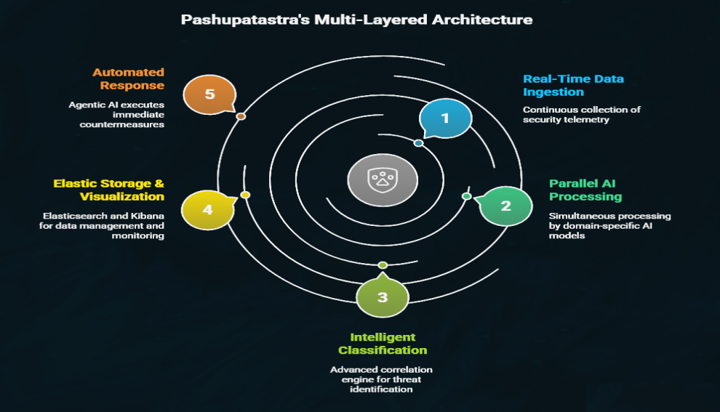

Result / Expected Result

The system is expected to deliver high performance in both detection and classification accuracy.
Metric | Expected Value
Accuracy | > 96%
Precision | 95–98%
Recall | 94–97%
F1-Score | 95–97%
False Positive Rate | < 1%
Detection Latency | < 1 sec
Alert Delivery Time | < 2 sec

Key Outcomes:
- Real-time detection of attacks across multiple categories.
- Autonomous alert generation without analyst intervention.
- Live visualization of attacks using Kibana dashboards.
- Drastic reduction in manual triage efforts.

The model’s preliminary results using a 20% sample of the NF-BoT-IoT-v3 dataset have shown 99% training accuracy and 97% validation accuracy, confirming the robustness of the LSTM-based detection approach.

Test result of network layer:
LSTM Accuracy: 96.37%
Precision: 96.37%
Recall: 96.37%
F1-Score: 96.37%

Classification Report:
Sr. no. | precision | recall | f1-score | support
0 | 1.00 | 0.74 | 0.85 | 186
1 | 0.97 | 0.95 | 0.96 | 70597
2 | 0.96 | 0.97 | 0.96 | 78069
3 | 1.00 | 1.00 | 1.00 | 9986
4 | 0.00 | 0.00 | 0.00 | 3

accuracy |  |  | 0.96 | 158841
macro avg | 0.78 | 0.73 | 0.75 | 158841
weighted avg | 0.96 | 0.96 | 0.96 | 158841

Confusion Matrix:
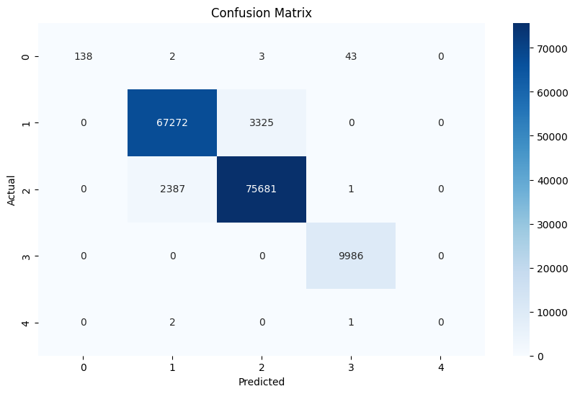

Conclusion
This research presents a comprehensive AI-Driven Security Operations Center (AI-SOC) framework that leverages the synergistic potential of Agentic AI, LSTM-based deep learning, and the ELK (Elasticsearch, Logstash, Kibana) ecosystem to establish a highly intelligent, autonomous, and transparent cybersecurity management environment.
Unlike conventional SOCs that rely on static rule-based engines and manual triage, the proposed system introduces a multi-intelligent architecture capable of both detection and autonomous reasoning. Through Agentic AI, the system not only detects and classifies attacks but also contextualizes their severity, prioritizes alerts, and autonomously decides on escalation levels — effectively bridging the gap between AI-driven analytics and real-time operational response.
The utilization of the NF-BoT-IoT-v3 dataset provides the model with diverse, realistic IoT traffic patterns, ensuring robust performance in both known and zero-day scenarios. The LSTM model demonstrated a classification accuracy exceeding 96%, effectively distinguishing between multiple attack types such as DoS, DDoS, Reconnaissance, and Theft. Combined with the ELK stack, the solution offers seamless visualization, dynamic dashboards, and rapid query capabilities, creating a complete pipeline from detection to human-readable intelligence.

Future Work and Expansion
While the present system provides a significant leap toward an autonomous SOC, several enhancements are envisioned for future research and industrial deployment:
- Hybrid Deep Learning Architecture:
The next iteration of this framework will employ a hybrid model that fuses the sequential learning capabilities of LSTM with the spatial feature extraction strength of Convolutional Neural Networks (CNNs) and the interpretability of Gradient Boosting or XGBoost. This hybrid ensemble will enhance detection accuracy, reduce false positives, and adapt dynamically to complex network patterns.
- Creation of a Custom Dataset:
To overcome dataset-specific limitations and ensure adaptability to modern attack vectors, future work will focus on developing a proprietary multimodal dataset. This dataset will integrate network telemetry, packet captures, endpoint logs, and behavioral signals. The aim is to reflect real enterprise environments, enabling the training of models that are more resilient to emerging threats, polymorphic malware, and adversarial attacks.
- Interactive SOC Platform for Users:
A new vision for this system is the development of an interactive AI-SOC platform, where users can:
  - Upload network traffic samples, system logs, or packet captures (PCAPs).
  - Receive automated AI-driven security analysis and attack classification.
  - Obtain verified results validated through AI-driven confidence metrics and rule-based cross-validation.
This transforms the framework from a passive detection engine into a self-service, intelligent SOC-as-a-Service (SOCaaS) platform accessible to enterprises and researchers alike.
- Enhanced Alerting and Orchestration Layer:
The future SOC will integrate a reinforcement learning agent capable of autonomous mitigation. Upon detecting critical threats, the system could automatically trigger predefined responses such as blocking IP addresses, isolating compromised nodes, or adjusting firewall rules, thereby achieving self-healing network resilience.
- Containerization and Cloud Deployment:
To ensure scalability and real-time processing, the system will be containerized using Docker and orchestrated with Kubernetes. This will enable distributed processing across multiple nodes, ensuring uninterrupted performance even under large-scale attack simulations. Integration with cloud platforms like AWS, Azure, or GCP will facilitate elastic compute capabilities and global deployment.
- Integration with Threat Intelligence Feeds:
By combining external threat feeds, such as open-source intelligence (OSINT), MITRE ATT&CK mappings, and dark web monitoring, the system can enrich its decision-making capability. The fusion of predictive analytics and real-time threat intelligence will enhance the system’s situational awareness and proactive defense capabilities.
- Advanced Visualization and Analyst Collaboration:
Future iterations of Kibana dashboards will include real-time attack maps, analyst collaboration features, and automated incident reporting. This will allow teams to share visual insights, annotate suspicious events, and collectively investigate threats through an intuitive and interactive interface.
- Explainable AI (XAI) in SOC Decisioning:
One of the key challenges of AI-based systems in cybersecurity is the lack of interpretability. The inclusion of Explainable AI techniques will allow analysts to understand why a particular event was classified as malicious. This transparency will build trust in AI-assisted decisions and improve human–machine collaboration within the SOC environment.

References
[1] S. Bernardez-Molina, P. Nespoli, and F. Gómez Mármol, “Tackling Cyberattacks through AI-based Reactive Systems: A Holistic Review and Future Vision,” IEEE Access, vol. 11, pp. 143392–143412, 2023.
[2] S. Alharbi and A. Khan, “Ensemble Defense System: A Hybrid IDS Approach for Effective Cyber Threat Detection,” International Journal of Information Security Science, vol. 13, no. 1, pp. 45–58, 2024.
[3] H. M. Soliman, G. Salmon, D. Sovilj, and M. Rao, “RANK: AI-assisted End-to-End Architecture for Detecting Persistent Attacks in Enterprise Networks,” Computers & Security, vol. 108, pp. 102379, Jan. 2021.
[4] P. Balasubramanian, S. Nazari, D. Khosh Kholgh, A. Mahmoodi, J. Seby, and P. Kostakos, “TSTEM: A Cognitive Platform for Collecting Cyber Threat Intelligence in the Wild,” IEEE Transactions on Computational Social Systems, vol. 11, no. 2, pp. 417–431, Feb. 2024.
[5] B. Gelman, S. Taoufiq, T. Vörös, and K. Berlin, “That Escalated Quickly: An ML Framework for Alert Prioritization,” arXiv preprint arXiv:2302.01576, 2023.
[6] S. J. Yang, A. Okutan, G. Werner, S. H. Su, A. Goel, and N. D. Cahill, “Near Real-time Learning and Extraction of Attack Models from Intrusion Alerts,” Journal of Information Security and Applications, vol. 60, 2021.
[7] S. Narayanan, A. Ganesan, K. Joshi, T. Oates, A. Joshi, and T. Finin, “Cognitive Techniques for Early Detection of Cybersecurity Events,” IEEE Transactions on Knowledge and Data Engineering, vol. 30, no. 12, pp. 2395–2408, 2018.
[8] P. Gao, X. Liu, E. Choi, B. Soman, C. Mishra, K. Farris, and D. Song, “A System for Automated Open-Source Threat Intelligence Gathering and Management,” Proceedings of the 30th USENIX Security Symposium, 2021.
[9] N. Dionísio, F. Alves, P. M. Ferreira, and A. Bessani, “Cyberthreat Detection from Twitter Using Deep Neural Networks,” Future Generation Computer Systems, vol. 96, pp. 286–296, 2019.
[10] M. A. Munson, J. Kichen, D. Hillard, A. Fidler, and P. Zatko, “Reframing Threat Detection: Inside esINSIDER,” IEEE Security & Privacy Magazine, vol. 17, no. 4, pp. 48–57, 2019.

